Test 1: Crashing at end of list

Nothing stopping the program from exceeding the number of records in the list before fix

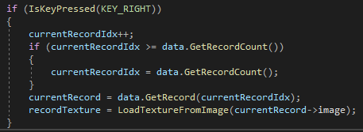

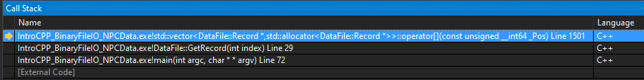

To fix, the if statement checking if the program is at the last record was slightly modified to keep the currentRecordIdx on the last record

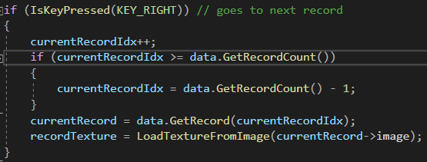

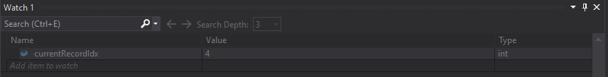

currentRecordIdx does go past 4

Test 2: Slow loading time

The program was loading every record into memory before fix

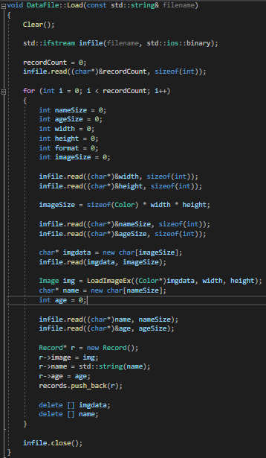

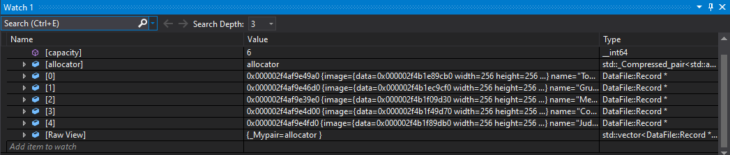

The program now loads the record that is needed

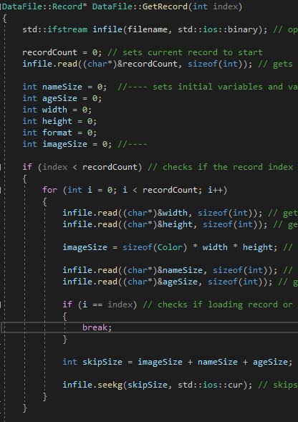

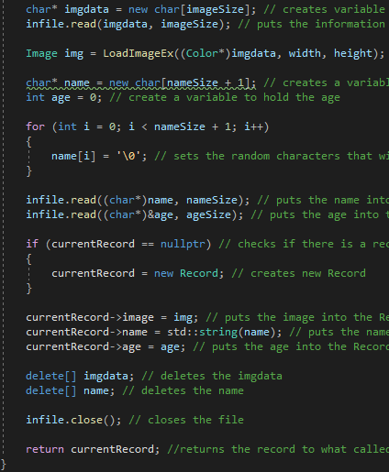

1st record

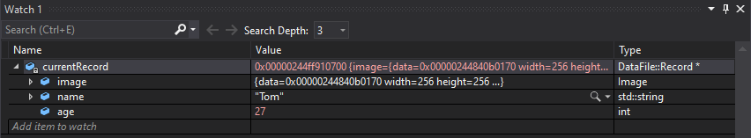

2nd record

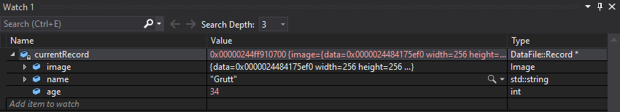

Test 3: Name printing correctly

Initial name value when created before fix

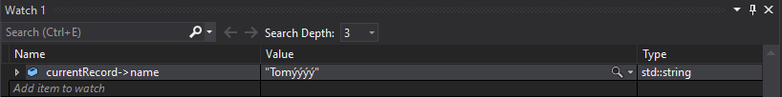

New name value after fix – clearing random characters in name variable

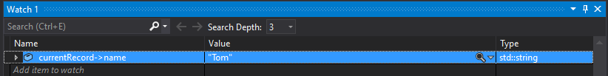

Cause for the bug – There was no null termination character included with the string.

Fix – Fill the needed characters in the name variable with null termination characters after initialising the variable and before inserting the name into the variable.

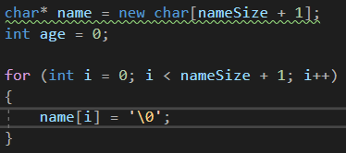

Debugging Keyboard Shortcuts:

Break All Ctrl + Alt + Break

Stop Debugging – Shift + F5

Restart – Ctrl + Shift + F5

Show Next Statement – Alt + Num \*

Step Into – F11

Step Over – F10

Step Out – Shift + F11

Step Forward – Alt + ]

Step Backward – Alt + [